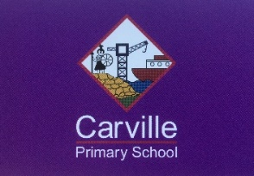
Reopening of school for your Reception child.

We are very excited about reopening school for your child and look forward to seeing them again. We know that you value the work of school, have supported your child’s education at home in your own ways and will be keen to send your child back to school as soon as possible. However, we are also aware that you will have some concerns about how safe it is at the moment. The informed decision to send your child back to school is still for you to make as a parent at the moment. The DfE guidance is clear that no fines or consequences will be issued for non-attendance.

We have worked hard to minimise the risk from coronavirus in school, but cannot make any guarantees. Please be assured that we have worked hard to meet all of the requirements of the government guidance, but as a result school will be different for a while. The videos on our website (https://www.carvilleprimary.co.uk/coronavirus-reopening) show you what a return to school looks like for your child and their small group ‘Bubble’. Specific details for your child are below:

- Your child is in the Butterflies Bubble (no more than 9 children). They will be taught by Miss Freed.
- Only 1 parent or carer will be allowed to drop off their child and the parent cannot enter the school grounds.
- Arrive at school between 9:10-9:30am. Please come to the main entrance gate on The Avenue where Mr Qualters or Mr Harker will greet you.
- Your child will enter through the white gate into Early Years. If you arrive after 9:30am, the gate will be closed and your child will not be able to come to school that day.
- Please apply sun cream before coming to school in the morning.
- Children should wear clean uniform or other school appropriate clothing, including flat shoes. Please give them a long-sleeved top to put on and take off and a coat if needed.
- They should bring nothing else to school (no PE kit, no bags, no books, no packed lunches, no water bottles, etc.) A packed lunch and drinks will be provided for all pupils every day. Children will not bring anything home from school.
- Your child should be collected from the main entrance gate between 3:00-3:10pm, except on Friday when they should be collected between 12:30-12:40pm.

Thank you for your patience and continued support as we look to open in a ‘Covid Secure’ way.

Yours Sincerely,
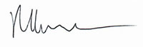

Mr. R Harker

